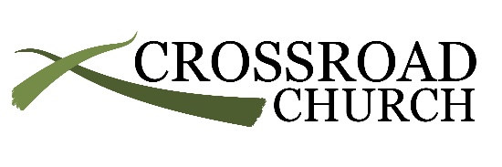
PLURALITY OF PASTORS (ELDER LED): The New Testament is clear about those who have the responsibility of rule, oversight, and care of the church. These men are called elders, overseers, and bishops. All three different titles are used to refer to the same pastoral spiritual office of leadership known as pastors in the church and are interchangeable. Christ is the head of the church and that He mediates His rule in the church through the loving shepherding of qualified pastors (elders). (Acts 6:2-6; Acts 15:1-35; Acts 20:17-18, 28-31; Galatians 1:6-9; 1 Thess. 5:12; 1 Timothy 1:3-7, 3:1-7, 5:17; 2 Timothy 4:2; Titus 1:5-16; Hebrews 13:7, 17; 1 Peter 5:1-4)

Strengths of Plurality Leadership:
- Biblical accountability. Godly fellow elders are a great means for holding the pastor accountable to live, teach, and lead faithfully. In addition, sharing authority among a number of men can keep one man from wrongly lording it over the congregation.
- Wisdom. There is more wisdom to be found in a multitude of counselors (Prov. 11:14; 24:6).
- Balance. No one man has all the gifts that are necessary to build up the church. Having a plurality of elders serves the church by bringing men with different gifts into the church’s leadership who can complement the pastor’s strengths.
- Burden sharing. Caring for the whole church is a burden God does not intend one man to bear alone. Even the most faithful, gifted pastor needs help from other godly men in order to pay careful attention to himself and to all the flock (Acts 20:28).
- Sets an example for the church. Having a plurality of elders demonstrates that the work of ministry is not reserved for a select few. Rather, it provides an example of maturity for every man, particularly when some of the elders are men who work ordinary jobs and are not paid by the church.

